AWS Simple Queue Service
Introduction
Amazon Web Services provides messaging services that help applications communicate securely and reliably.
AWS offers:
- AWS SQS (Simple Queue Service)
- Amazon MQ
These services are used in distributed applications and microservices architecture.
AWS SQS (Simple Queue Service)
- AWS SQS is a fully managed message queuing service used to send, store, and receive messages between applications.
- It helps applications communicate asynchronously.
Purpose of AWS SQS
SQS is used to:
- Decouple applications
- Store messages temporarily
- Improve scalability
- Prevent data loss
- Handle background tasks
How AWS SQS Works
Workflow
Producer → SQS Queue → Consumer
Explanation
- Producer sends message to queue
- SQS stores message
- Consumer receives and processes message
- Message deleted after processing

Types of SQS Queues
1. Standard Queue
Features
- High throughput
- Best effort ordering
- At least once delivery
Use Cases
- Background processing
- Order processing
- Notifications

2. FIFO Queue
FIFO = First In First Out
Features
- Exact message order
- No duplicate messages
Use Cases
- Banking systems
- Payment processing
- Inventory systems

Features of AWS SQS
- Fully managed service
- Unlimited scalability
- Secure messaging
- Message retention
- Dead-letter queues
- Encryption support

Advantages of SQS
- Reliable messaging
- Serverless architecture
- Easy integration
- Cost effective
- High availability

SQS Components
Component | Description
Queue | Stores messages
Producer | Sends messages
Consumer | Receives messages
Message | Data sent through queue

SQS Security Features
- IAM policies
- SSE encryption
- HTTPS communication
- Access control

Message Retention
Messages can be stored:
- Minimum: 1 minute
- Maximum: 14 days

Visibility Timeout
When a consumer reads a message:
- Message becomes invisible temporarily
- Prevents duplicate processing

Dead Letter Queue (DLQ)
Used for failed messages.
Benefits:
- Error tracking
- Debugging failed processing

AWS Services Integrated with SQS
- Lambda
- EC2
- SNS
- CloudWatch
- Auto Scaling

Real-Time Use Case
E-Commerce Application
Customer Order → SQS Queue → Order Processing Server
Explanation
Orders are stored safely in queue until processing completes.
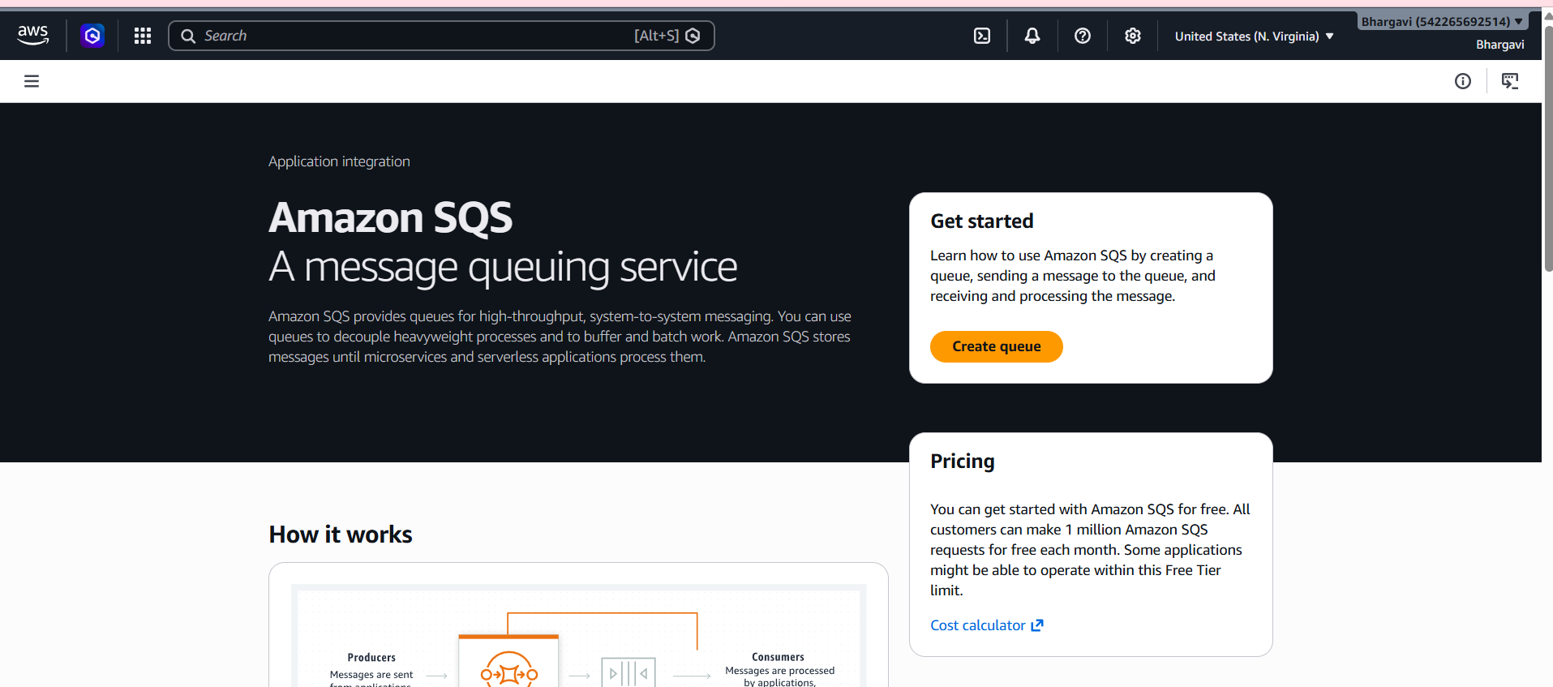
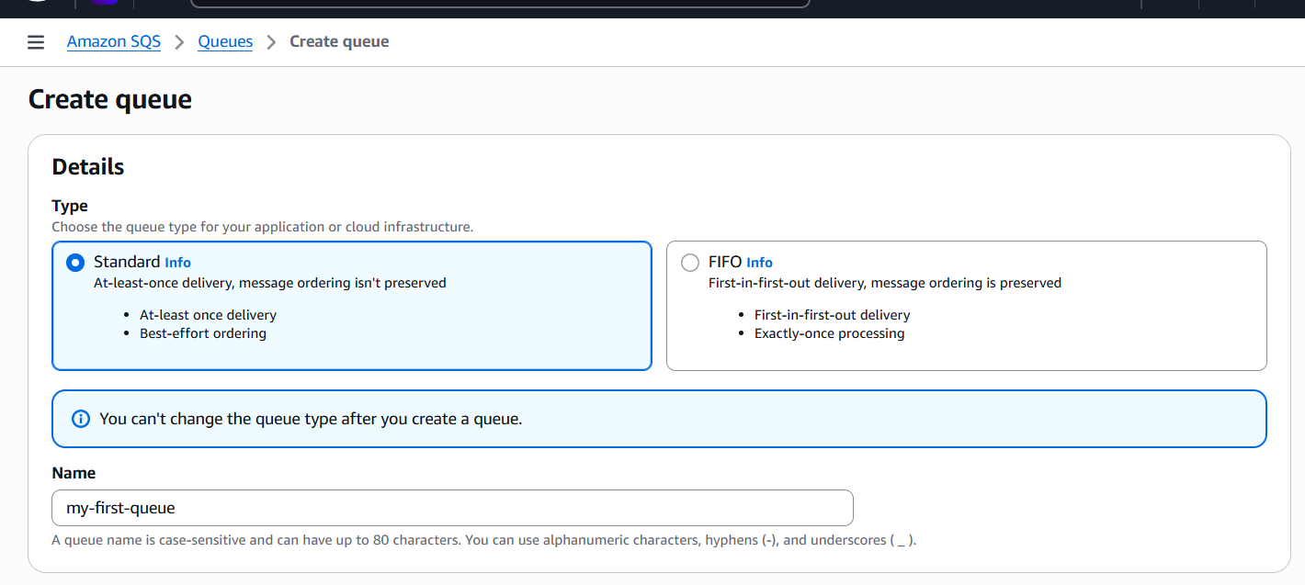
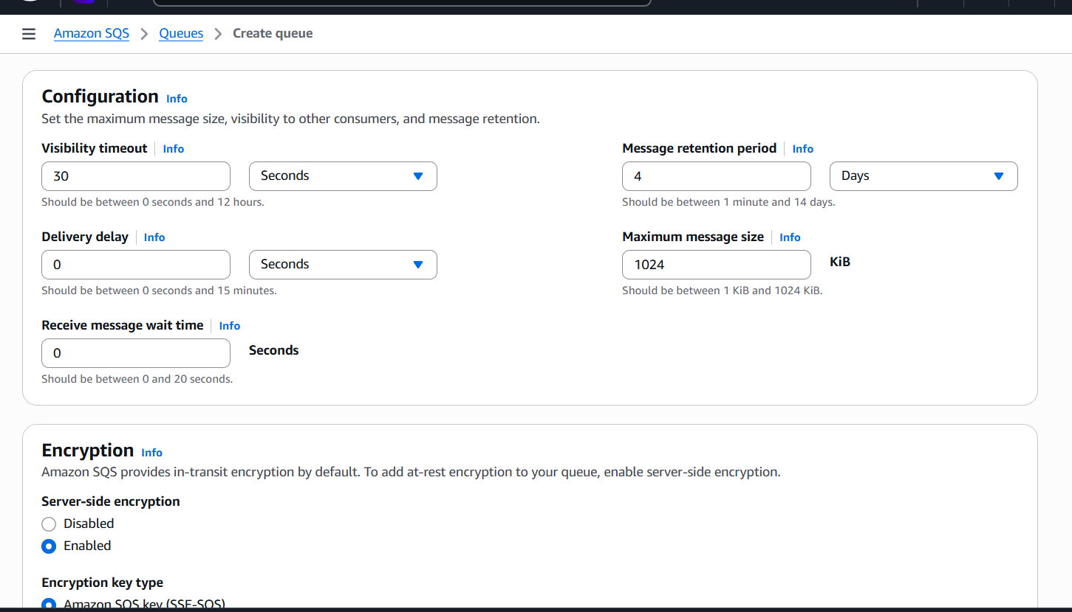
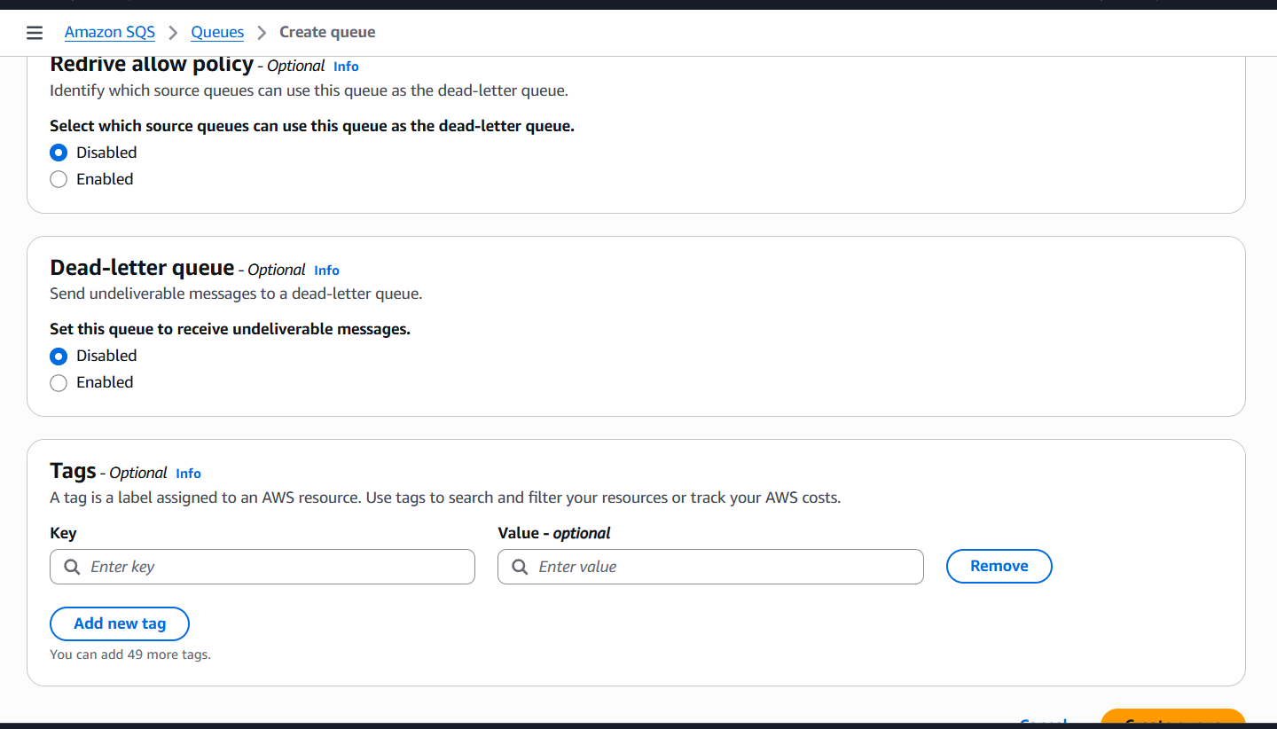
Nothing to change create queue.
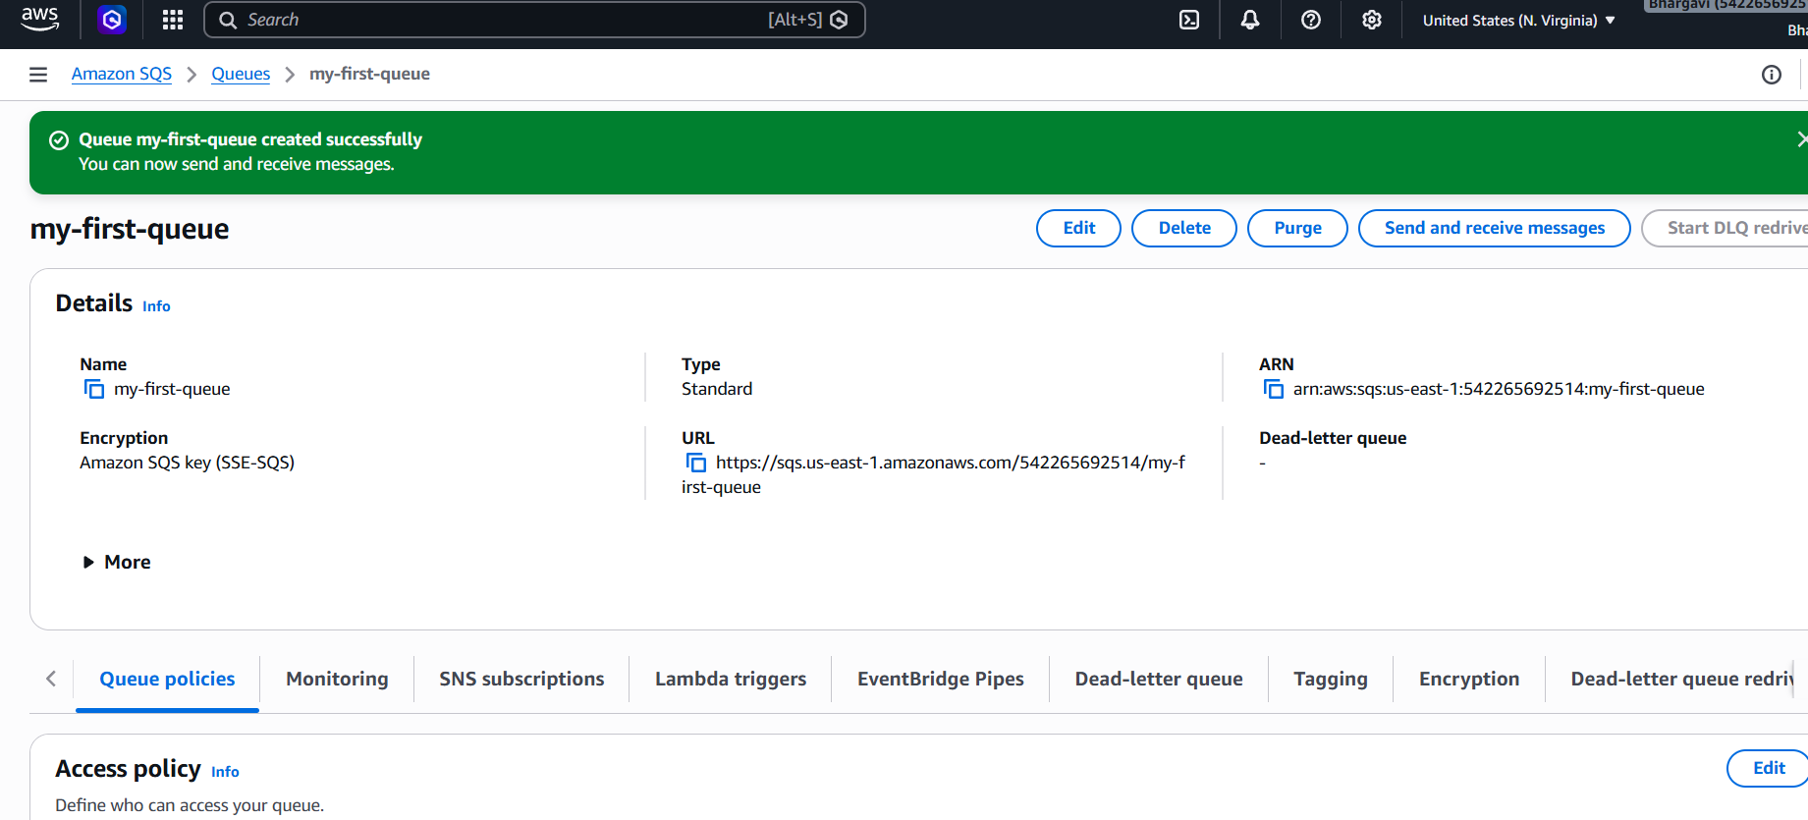
Sending Messages to QueueOpen created queueSend and Receive MessagesEnter message:Hello AWS SQSSend Message--Poll for Messages--Monitoring SQS
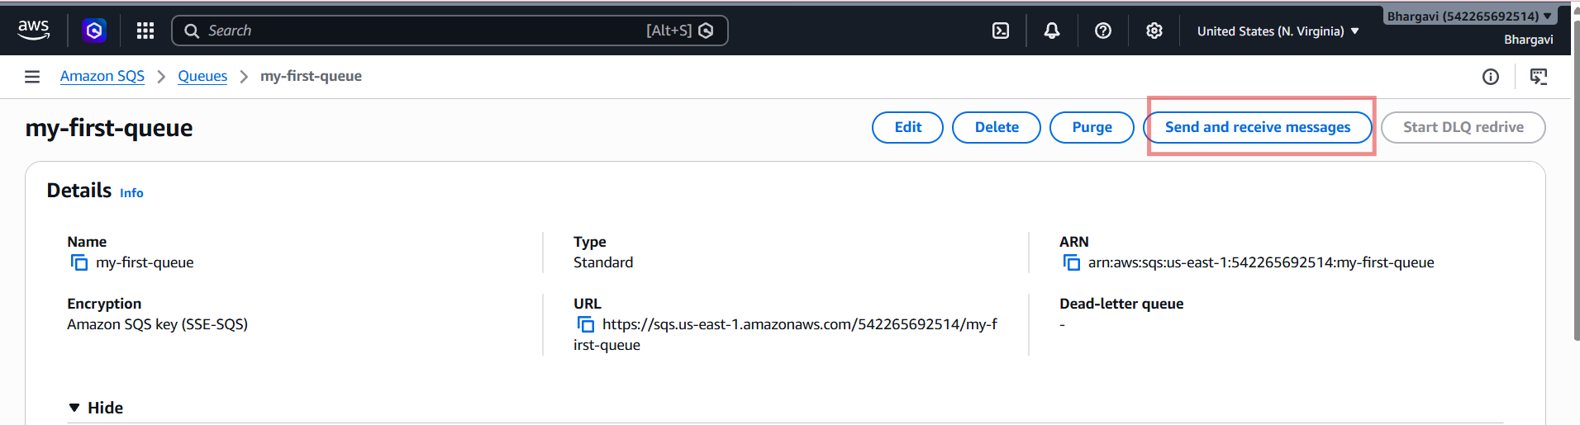
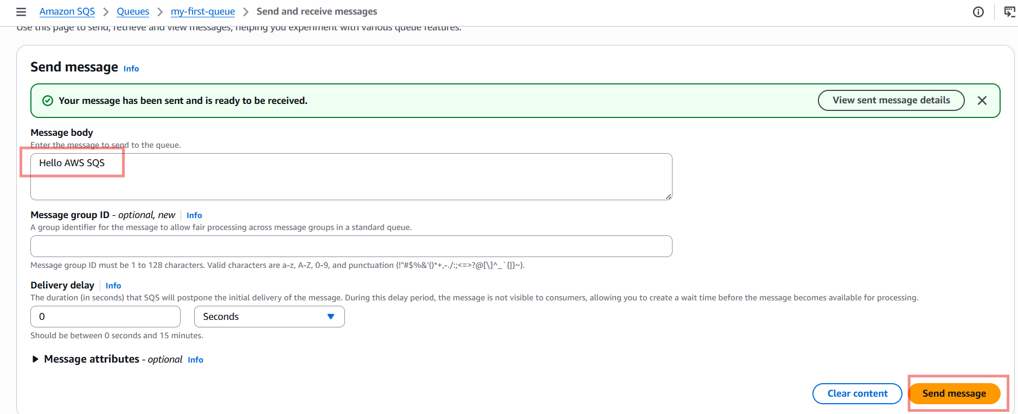
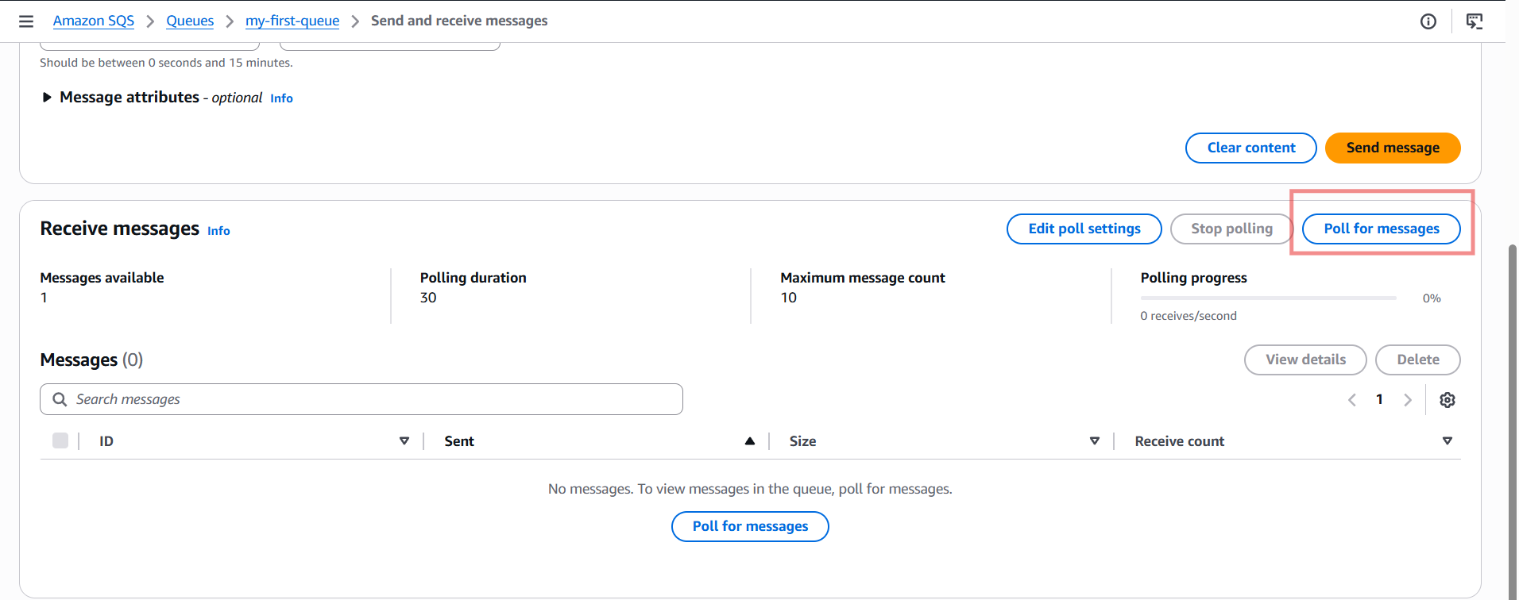
Receive Message
Scroll to:Receive Messages--Click:--Poll for Messages-Now your stored message appears.
Example:Hello AWS SQS

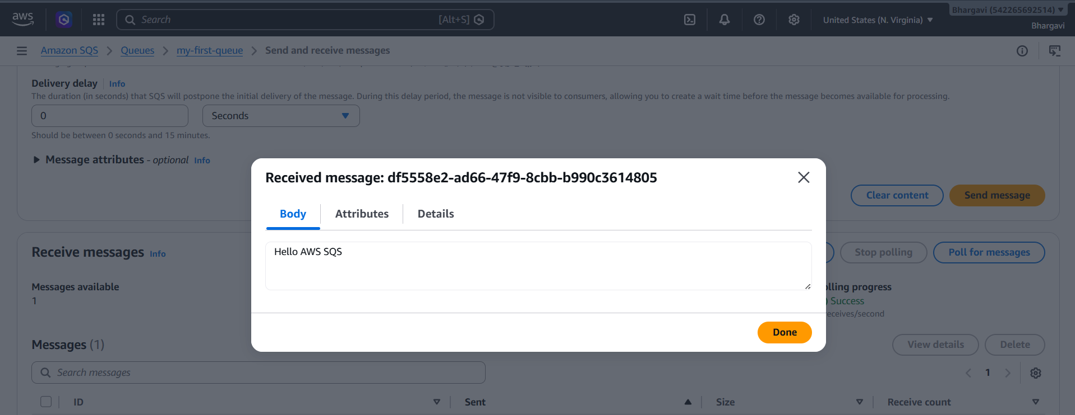
Delete Message
After reading message:Select message checkbox.
Click:Delete
Message removed from queue.

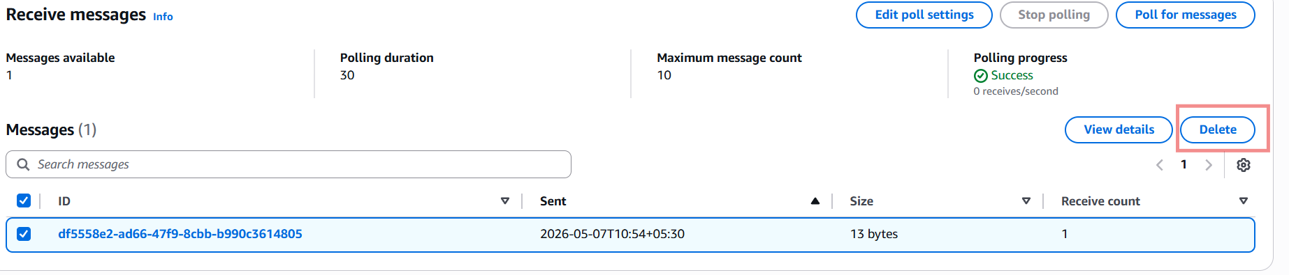
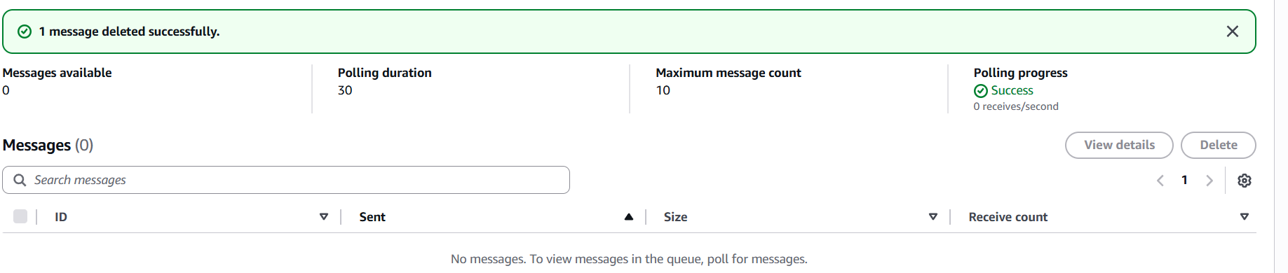
Monitor Queue
Go to:Monitoring—You can check:
- Messages sent
- Messages received
- Queue traffic Integrated with CloudWatch.
